Name Alex Lundin

Class SE 4367.001 - Software Testing

Assignment Homework #10

FSM

A.)

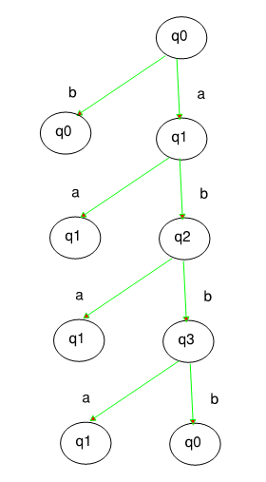

B.) Transition cover set P is a set of all strings, representing sub paths from the root in the testing tree.P= { ε, b, a, aa, ab, aba, abb, abbba, abbbb}